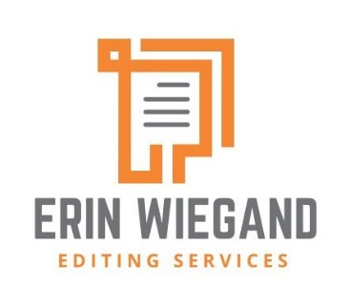
Client Intake Form – Copyediting

Name:

Please briefly describe the project (both the topic and the type of work it is—a book, a journal article, a workbook):

Length of manuscript:

Are there any images, tables, exercises, or other special sections? Please describe, if so:

Where are you in the process? Is the manuscript ready for editing now, and if not, when will it be complete? Are you able to provide a sample to review?

Have any other editors (or agents, or peer reviewers) given you feedback on the manuscript?

What is your timeline, and what is the hard due date for completing the copyedit?

What are your publication plans for this work? If you are submitting it to a journal or a publishing house, please let me know where you’re hoping to send it (or if you have a contract already in place).

What style guide, if any, should be used? What spelling/punctuation would you like to follow (e.g., US/UK/Canadian)?

Here are a few common types of editing:
Copyediting addresses issues of clarity, concision, and consistency; a copyedit will primarily look for errors and inconsistency when it comes to spelling, punctuation, and other issues of style. A copyeditor will also look for grammatical errors and will query sentences that are unclear or flag where additional information is needed.
Line editing, or heavier copyediting, will suggest cuts to avoid redundancy or repetition and rewrites of sentences to make them clearer and smoother. A line editor may suggest moving paragraphs within or even between chapters. As a line editor, I will also flag any issues of logical inconsistency, unsupported claims, and potentially harmful or offensive language.
Proofreading is a detail-oriented process that occurs after a book has been designed and typeset. A proofreader checks for typesetting errors and provides a final pass over the text to catch small errors missed during copyediting, such as spelling mistakes, stylistic inconsistency, or grammatical errors. A “proofread” should only occur once pages have been designed—if the text you’re editing is still in a Word document, it might be called a “light copyedit.”
Which of these kinds of editing—copyediting, line editing, or proofreading—are you looking for at this stage?

Finally, I’d appreciate knowing where you heard about me and my services (through a colleague, recommended by another editor, via Google search or the CIEP editors’ directory, etc.). Thanks very much for your interest!

Erin Wiegand

